
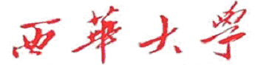
计算机与软件工程学院
上机实验报告

（ 2017/2018 学年 第 2 学期 ）

课程名称 | Java EE技术开发
课程代码 | 150901089
任课教师 | 陆园
学生姓名 | 文攀锋 | 年级 | 2015
学号 | 3120150901107 | 专业 | 计算机科学与技术
实验成绩

实验名称 | 实验2： Servlet综合实验1 |  |  | 实验地点 | 6A-XXX
实验类型 | 设计 | 实验学时 | 2 | 实验日期 | 20 /X/X
- 撰写注意：版面格式已设置好（不得更改），填入内容即可。
- 实验目的
(1) 掌握JSP基本语法。
(2) 掌握Servlet中，获取表单域数据的应用。

- 实验内容

- 程序设计
1.实现用户登录与注册系统的设计
①．用户注册页面
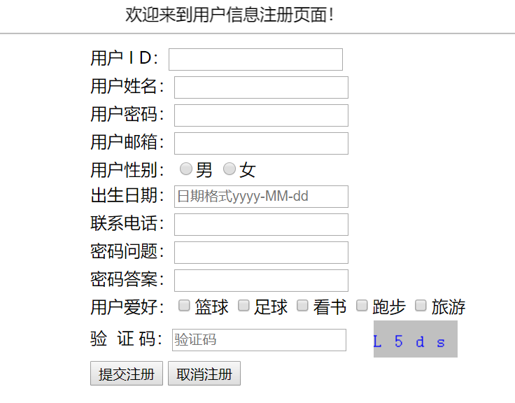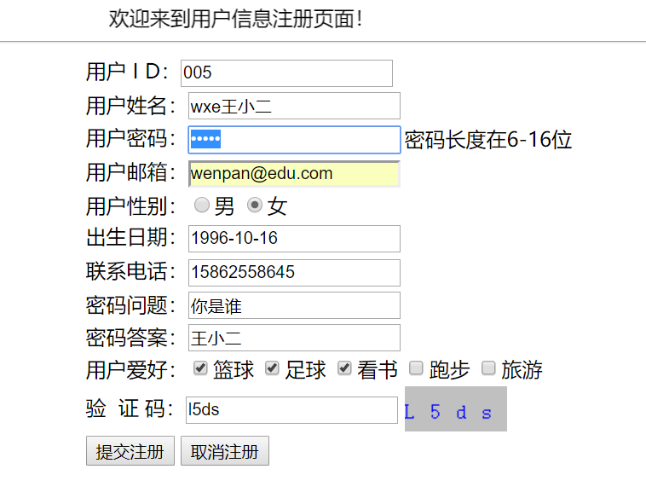
②．注册成功后的页面，然后自动跳转到登录页面让用户进行登录操作
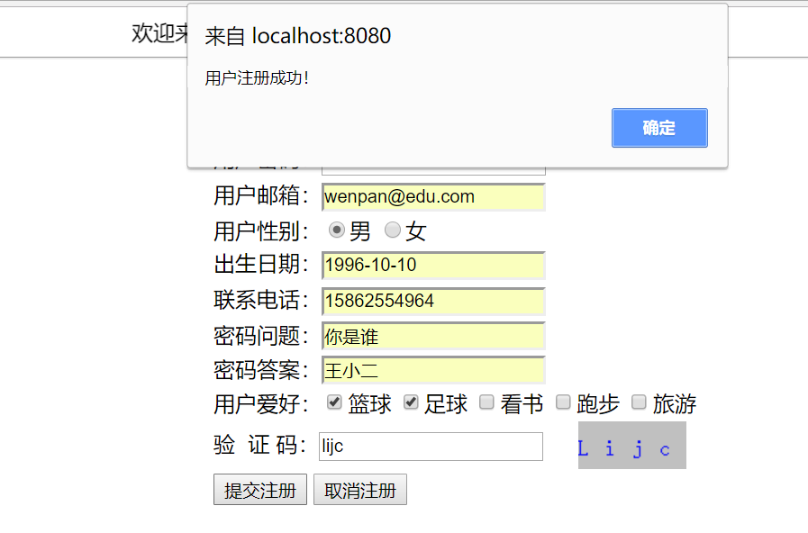
登录操作，登录成功后自动跳转到操作页面：
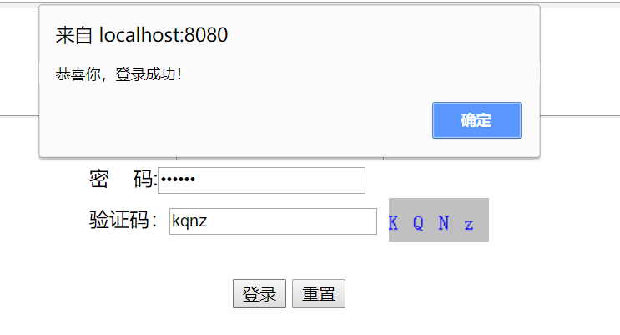
操作页面：
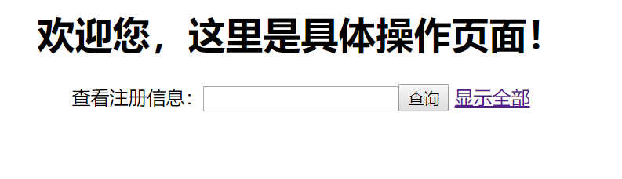
2.实现用户添加、删除、修改、查询
①．登录成功后进行查询操作：
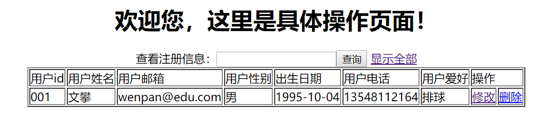
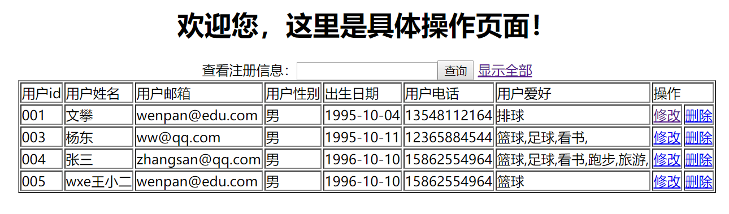
②．进行修改操作：
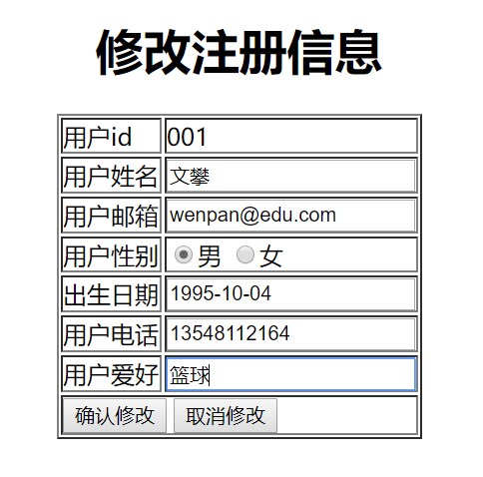
③．删除操作，删除姓名为wxe王小二的用户：
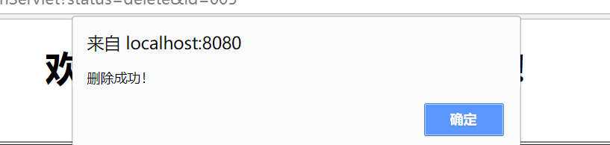
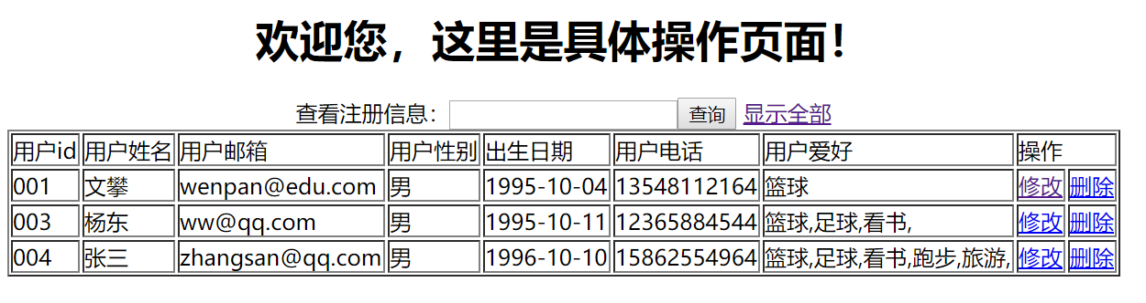

3.实现Servlet的文件上传和下载
①．在用户修改的页面进行上传自己的文件
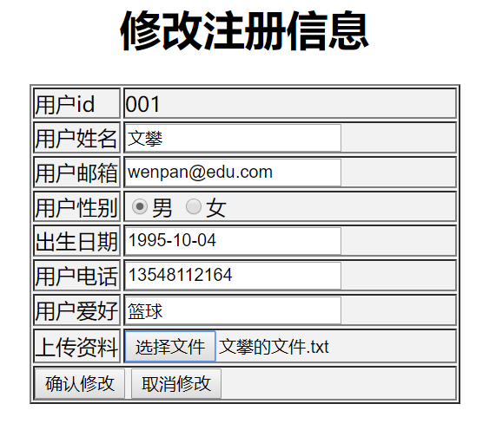
②．在用户修改的页面进行文件的下载操作

- 实验总结：
在本次实验中，明显比实验一具有更大的难度，程序设计起来也比实验一难度更大，最开始我不是很清楚JSP+JavaBean+Servlet(+DAO+JDBC+)开发模式，但是通过这次实验，我深入的理解了JSP+JavaBean+Servlet(+DAO+JDBC+)开发模式，在jdbc数据库操作中，我学会了利用c3p0来进行数据库相关操作，也学会了使用Dbutils来进行数据库的操作，使数据库的操作更加的方便，维护也更加的简单。我深刻的认识到了MVC开发模式给后期的维护工作带来了多大的便利。也深刻的理解了文件的上传与下载操作。现在对于java的学习路线也更加的清晰明了。在此，感谢在这次实验中对我提供帮助的同学和老师。希望老师以后能更多的给与我们这样的锻炼机会。

- 实验环境
- 操作系统：WINDOWS 7及以上
- 开发工具：VC++ 2012
- 实验设备：PC
- 提交文档
提交本实验报告（电子版），文件名命名：学号 姓名《实验X：XXXXXXX》.doc
教师将批阅后（有分数）的全体学生实验报告刻入一张光盘存档，保证光盘可读。
- 附：源代码
核心代码如下：
package com.wp.test.servlet;
import java.io.IOException;
import java.util.List;
import javax.servlet.ServletException;
import javax.servlet.annotation.WebServlet;
import javax.servlet.http.HttpServlet;
import javax.servlet.http.HttpServletRequest;
import javax.servlet.http.HttpServletResponse;

import com.wp.test.Factory.StaticFactory;
import com.wp.test.vo.User;

/**
* 登录servlet
*/
@WebServlet("/LoginServlet")
public class LoginServlet extends HttpServlet {
private static final long serialVersionUID = 1L;

protected void doGet(HttpServletRequest request, HttpServletResponse response) throws ServletException, IOException {

String msg = "登录失败！请重新登录！";
String pages = "login/login.jsp";
String id = request.getParameter("id");
String password = request.getParameter("password");
String inputcode = request.getParameter("code");
String code = (String) request.getSession().getAttribute("code");

if(code.equalsIgnoreCase(inputcode)) { //验证码通过
try {
List<User> users = StaticFactory.getIUserDAOInstance().findLogin(id);
if(users != null && users.size() > 0) { //若数据库中存在该用户
if(password.equals(users.get(0).getPassword())) { //登录成功
request.getSession().setAttribute("username",users.get(0).getId()); //将用户id保存到session属性域中
pages = "shiyan2/login_do.jsp";
msg = "恭喜你，登录成功！";
}
}
} catch (Exception e) {
e.printStackTrace();
}
}else {
pages = "shiyan2/loginfail_do.jsp";
}

request.setAttribute("msg",msg);
request.getRequestDispatcher(pages).forward(request, response);
}
protected void doPost(HttpServletRequest request, HttpServletResponse response)
throws ServletException, IOException {
doGet(request, response);
}

}

package com.wp.test.servlet;

import java.io.IOException;

import javax.servlet.ServletException;
import javax.servlet.annotation.WebServlet;
import javax.servlet.http.HttpServlet;
import javax.servlet.http.HttpServletRequest;
import javax.servlet.http.HttpServletResponse;

import org.apache.commons.beanutils.BeanUtils;

import com.wp.test.vo.User;

@WebServlet("/RegisterServlet")
public class RegisterServlet extends HttpServlet {
private static final long serialVersionUID = 1L;

protected void doGet(HttpServletRequest request, HttpServletResponse response) throws ServletException, IOException {
request.setCharacterEncoding("GBK");
response.setCharacterEncoding("GBK");

this.add(request, response);
}

protected void doPost(HttpServletRequest request, HttpServletResponse response) throws ServletException, IOException {
doGet(request, response);
}
//=======================================================================================================================================
public void add(HttpServletRequest request, HttpServletResponse response) throws ServletException, IOException{
String pages = "shiyan2/registerfail_do.jsp";
String msg = "已存在该信息，注册失败！请重新注册";
String inputcode = request.getParameter("code"); //取得输入的验证码
String code = (String) request.getSession().getAttribute("code"); //取得生成的验证码
User user = new User();

if(inputcode.equalsIgnoreCase(code)) {
try {
BeanUtils.populate(user, request.getParameterMap()); //取得全部提交的信息并封装成对象
} catch (Exception e) {
e.printStackTrace();
}
String[] str = request.getParameterValues("hobby");
StringBuffer stringBuffer = new StringBuffer();
for(int i = 0;i < str.length;i++) {
stringBuffer = stringBuffer.append(str[i]);
if(i!=str.length - 1) {
stringBuffer.append(",");
}
}
//System.out.println(stringBuffer.toString());
//user.setHobby(stringBuffer.toString());
//System.out.println(user);

try {
if(com.wp.test.Factory.StaticFactory.getIUserDAOInstance().registerUser(user)) { //进行用户注册
msg = "用户注册成功！";
pages = "shiyan2/register_do.jsp";
}
} catch (Exception e) { //对该异常不进行处理 sql异常

}

}else{
msg = "验证码错误！";
}

request.setAttribute("msg", msg);
request.getRequestDispatcher(pages).forward(request, response);
}
}

package com.wp.test.servlet;

import java.io.IOException;
import java.util.List;

import javax.servlet.ServletException;
import javax.servlet.annotation.WebServlet;
import javax.servlet.http.HttpServlet;
import javax.servlet.http.HttpServletRequest;
import javax.servlet.http.HttpServletResponse;

import org.apache.commons.beanutils.BeanUtils;

import com.wp.test.Factory.StaticFactory;
import com.wp.test.vo.User;

/**
* 进行注册用户的增删改查操作
*/
@WebServlet("/UserOperationServlet")
public class UserOperationServlet extends HttpServlet {
private static final long serialVersionUID = 1L;

protected void doGet(HttpServletRequest request, HttpServletResponse response) throws ServletException, IOException {
request.setCharacterEncoding("GBK");
response.setCharacterEncoding("GBK");

String status = request.getParameter("status");
if("queryUser".equals(status)) {
this.queryUser(request, response);
}
if("queryAll".equals(status)) {
this.queryAll(request, response);
}
if("updatepre".equals(status)) {
this.updatepre(request, response);
}
if("update".equals(status)) {
this.update(request, response);
}
if("delete".equals(status)) {
this.delete(request, response);
}

}

protected void doPost(HttpServletRequest request, HttpServletResponse response) throws ServletException, IOException {
doGet(request, response);
}

//=======================================================================================================================================

public void queryUser(HttpServletRequest request, HttpServletResponse response) throws
ServletException, IOException {
String pages = "errors.jsp";
String id = request.getParameter("keyword");
List<User> all = null;
System.out.println(id);
if(id == null) {
id = ""; //默认查询全部
}
try {
all = StaticFactory.getIUserDAOInstance().findLogin(id);
pages = "shiyan2/welcome.jsp";
} catch (Exception e) {
e.printStackTrace();
}

request.setAttribute("all", all);

request.getRequestDispatcher(pages).forward(request, response);
}

public void queryAll(HttpServletRequest request, HttpServletResponse response) throws
ServletException, IOException {
String pages = "errors.jsp";
List<User> all = null;

try {
all = StaticFactory.getIUserDAOInstance().findAll();
pages = "shiyan2/welcome.jsp";
} catch (Exception e) {
e.printStackTrace();
}

request.setAttribute("all", all);
request.getRequestDispatcher(pages).forward(request, response);
}

public void delete(HttpServletRequest request, HttpServletResponse response) throws
ServletException, IOException {
String pages = "errors.jsp";
String msg = "删除失败！";
String id = request.getParameter("id");
try {
if(StaticFactory.getIUserDAOInstance().deleteUser(id)) {
pages = "shiyan2/delete_do.jsp";
msg = "删除成功！";
}
} catch (Exception e) {
e.printStackTrace();
}

request.setAttribute("msg", msg);
request.getRequestDispatcher(pages).forward(request, response);
}

public void updatepre(HttpServletRequest request, HttpServletResponse response) throws
ServletException, IOException {
String pages = "errors.jsp";
List<User> all = null;
String id = request.getParameter("id");
try {
all = StaticFactory.getIUserDAOInstance().findLogin(id);
pages = "shiyan2/update.jsp";
} catch (Exception e) {
e.printStackTrace();
}

request.setAttribute("all", all);
request.getRequestDispatcher(pages).forward(request, response);
}

public void update(HttpServletRequest request, HttpServletResponse response) throws
ServletException, IOException {
String pages = "errors.jsp";
String msg = "修改用户信息失败！";
User user = new User();

try {
BeanUtils.populate(user, request.getParameterMap()); //自动将提交过来的信息封装为一个emp对象,不在一个一个的接收了
if(StaticFactory.getIUserDAOInstance().updateUser(user)) {
pages = "shiyan2/update_do.jsp";
msg = "修改用户信息成功！";
}

} catch (Exception e) {
e.printStackTrace();
}

request.setAttribute("msg",msg);
request.getRequestDispatcher(pages).forward(request, response);

}
}

package com.wp.test.dao.impl;

import java.sql.Connection;
import java.sql.PreparedStatement;
import java.sql.SQLException;
import java.util.List;

import org.apache.commons.dbutils.QueryRunner;
import org.apache.commons.dbutils.handlers.BeanListHandler;

import com.wp.test.dao.IUserDAO;
import com.wp.test.vo.User;

public class UserDAOImpl implements IUserDAO{

Connection conn = null;
PreparedStatement pstmt = null;
public UserDAOImpl(Connection conn) {
this.conn = conn;
}

@Override
public boolean registerUser(User user) throws Exception {
boolean flag = false;
QueryRunner runner = new QueryRunner(); //带有事务回滚
String sql = "insert into myuser(id,name,password,email,gender,birthday,phone,question,answer,hobby) values(?,?,?,?,?,?,?,?,?,?)";
Object params[] = {user.getId(),user.getName(),user.getPassword(),user.getEmail(),user.getGender(),user.getBirthday(),
user.getPhone(),user.getQuestion(),user.getAnswer(),user.getHobby()}; //设置sql语句的参数

if(runner.update(conn, sql, params) > 0) { //执行插入操作
flag = true;
}
return flag;
}

@Override
public boolean deleteUser(String id) throws Exception {
boolean flag = false;
QueryRunner runner = new QueryRunner();
String sql = "delete myuser where id = ?";
if(runner.update(conn, sql,id) > 0) { //执行删除成功
flag = true;
}
return flag;
}

@Override
public boolean updateUser(User user) throws SQLException {
boolean flag = false;
QueryRunner runner = new QueryRunner();
String sql = "update myuser set name = ?,email = ?,gender = ?,birthday=?,phone=?,hobby=? where id = ?";
Object params[] = {user.getName(),user.getEmail(),user.getGender(),user.getBirthday(),user.getPhone(),user.getHobby(),user.getId()};

if(runner.update(conn, sql, params) > 0) { //执行更新
flag = true;
}
return flag;
}

/* 用户id、name(姓名)、password(密码)、email(邮箱)、gender(性别)、birthday(出生日期)、
phone(电话)、question(密码问题)、answer(密码答案)、hobby(爱好)*/

@Override
public List<User> findLogin(String id) throws Exception { //根据id查找
//BeanListHandler：将结果集中的每一行数据都封装到一个对应的JavaBean实例中，存放到List里。
QueryRunner runner = new QueryRunner(com.wp.test.dao.database.JDBCUtils.getDataSource()); //创建一个queryRuner
String sql = "select id,name,password,email,gender,birthday,phone,question,answer,hobby from myuser where "
+ " id like ? or name like ? or gender like ? order by id";
String[] params = {id,id,id};
List<User> list = runner.query(sql, new BeanListHandler<>(User.class),params); //执行查询操作，并且将查询结果保存到list集合

return list;
}

@Override
public List<User> findAll() throws Exception {
//BeanListHandler：将结果集中的每一行数据都封装到一个对应的JavaBean实例中，存放到List里。
QueryRunner runner = new QueryRunner(com.wp.test.dao.database.JDBCUtils.getDataSource()); //创建一个queryRuner
String sql = "select id,name,password,email,gender,birthday,phone,question,answer,hobby from myuser order by id";
List<User> list = runner.query(sql, new BeanListHandler<>(User.class)); //执行查询操作，并且将查询结果保存到list集合

return list;
}
}

package com.wp.test.dao.database;

import java.sql.Connection;
import java.sql.SQLException;

import javax.sql.DataSource;

import com.mchange.v2.c3p0.ComboPooledDataSource;

public class JDBCUtils {

public static DataSource dataSource = null;

static {
dataSource = new ComboPooledDataSource("helloC3P0"); //从配置文件中获取数据源
}

public static DataSource getDataSource() {
return dataSource; //返回数据源
}

public static Connection getConnection() { //返回数据库连接
Connection conn = null;
try {
conn = dataSource.getConnection();
} catch (SQLException e) {
e.printStackTrace();
}
return conn;
}

public static void close(Connection conn) { //关闭数据库连接
if(conn != null) {
try {
conn.close();
} catch (SQLException e) {
e.printStackTrace();
}
}
}
}

package com.wp.test.dao.proxy;

import java.sql.Connection;
import java.util.List;

import com.wp.test.dao.IUserDAO;
import com.wp.test.dao.database.JDBCUtils;
import com.wp.test.dao.impl.UserDAOImpl;
import com.wp.test.vo.User;

public class UserDAOProxy implements IUserDAO{

private Connection conn = null;
private IUserDAO dao = null;

public UserDAOProxy() {
this.conn = JDBCUtils.getConnection();
this.dao = new UserDAOImpl(this.conn);
}

@Override
public boolean registerUser(User user) {
boolean flag = false;
try {
if(this.dao.findLogin(user.getId()).size() == 0) { //若数据库中不存在这个对象
flag = this.dao.registerUser(user);
}
} catch (Exception e) {
e.printStackTrace();
}
return flag;
}

@Override
public boolean deleteUser(String id) throws Exception{
boolean flag = false;
try {
flag = this.dao.deleteUser(id);
} catch (Exception e) {
e.printStackTrace();
}
return flag;
}

@Override
public boolean updateUser(User user) {
boolean flag = false;
try {
flag = this.dao.updateUser(user);
} catch (Exception e) {
e.printStackTrace();
}
return flag;
}

@Override
public List<User> findLogin(String id) throws Exception {
List<User> all = null;
try {
all = this.dao.findLogin(id);
} catch (Exception e) {
e.printStackTrace();
}
return all;
}

@Override
public List<User> findAll() throws Exception {
List<User> all = null;
try {
all = this.dao.findAll();
} catch (Exception e) {
e.printStackTrace();
}
return all;
}
}

